Worksheet 2
Student Name:Anjali kumari UID: 25MCA20023
Branch: MCA(GENRAL) Section/Group:25MCA-1-A
Semester: III Date of Performance:27/8/26
Subject Name: Internet Of Things Subject Code:25-CAH

Aim/Overview of the practical: (ODD UIDS)
Interface an Arduino Uno with LEDs to design the different patterns and follow the different cases. Use 6 different color LEDs and name them T1 to T6 and use resistors of suitable values.
  - T1, T2 and T3 are in ON condition and T4, T5 and T6 are in Off conditions.
  - T1, T2 and T3 are in OFF condition and T4, T5 and T6 are in ON conditions.
  - T1, T3 and T5 are in ON conditions and T2, T4 and T6 are in OFF conditions.
  - T1, T3 and T5 are in OFF conditions and T2, T4 and T6 are in ON conditions.

Apparatus:
Hardware Requirements: Arduino Uno R3
Breadboard LED
Jumper Wires

Software requirements: TinkerCAD
MS Windows 10 Arduino IDE

Circuit Diagram(TinkerCad):
  - T1, T2 and T3 are in ON condition and T4, T5 and T6 are in Off conditions

Coding:
int led1 = 13; int led2 = 12; int led3 = 11; int led4 = 10; int led5 = 9; int led6 = 8;

void setup(){
//setting all pins as output pinMode(led1 , OUTPUT);

pinMode(led2 , OUTPUT); pinMode(led3, OUTPUT); pinMode(led4 , OUTPUT); pinMode(led5 , OUTPUT); pinMode(led6 , OUTPUT);
}
void loop(){
//First led 3 ON digitalWrite(led1 , HIGH); digitalWrite(led2 , HIGH); digitalWrite(led3 , HIGH);

//LAST 3 OFF
digitalWrite(led4 , LOW); digitalWrite(led5 , LOW); digitalWrite(led6 , LOW);

//DELAY
delay(2000);
}

Output:
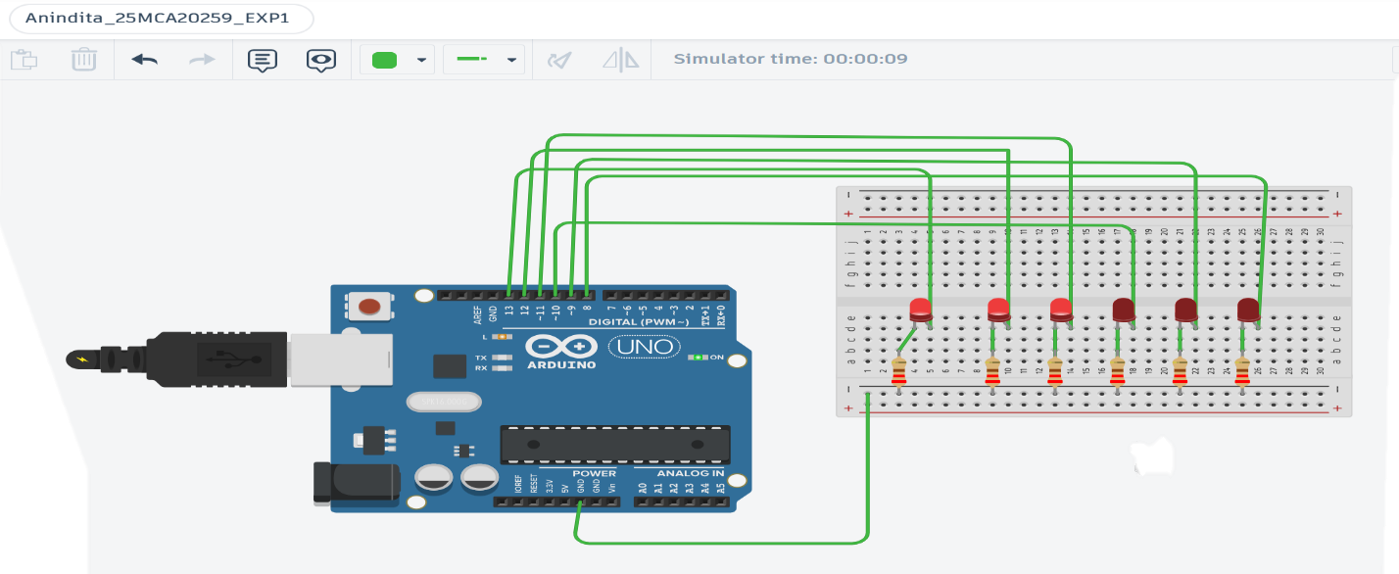
  - T1, T2 and T3 are in OFF condition and T4, T5 and T6 are in ON conditions.

Coding:
int led1 = 13; int led2 = 12; int led3 = 11; int led4 = 10; int led5 = 9; int led6 = 8;

void setup(){
//setting all pins as output pinMode(led1 , OUTPUT); pinMode(led2 , OUTPUT); pinMode(led3, OUTPUT); pinMode(led4 , OUTPUT); pinMode(led5 , OUTPUT); pinMode(led6 , OUTPUT);
}

void loop(){
//FIRST 3 OFF
digitalWrite(led1, LOW); digitalWrite(led2 ,LOW); digitalWrite(led3 , LOW);
//LAST 3 ON
digitalWrite(led4 , HIGH); digitalWrite(led5 , HIGH); digitalWrite(led6 ,HIGH);

delay(2000);
}

Output:
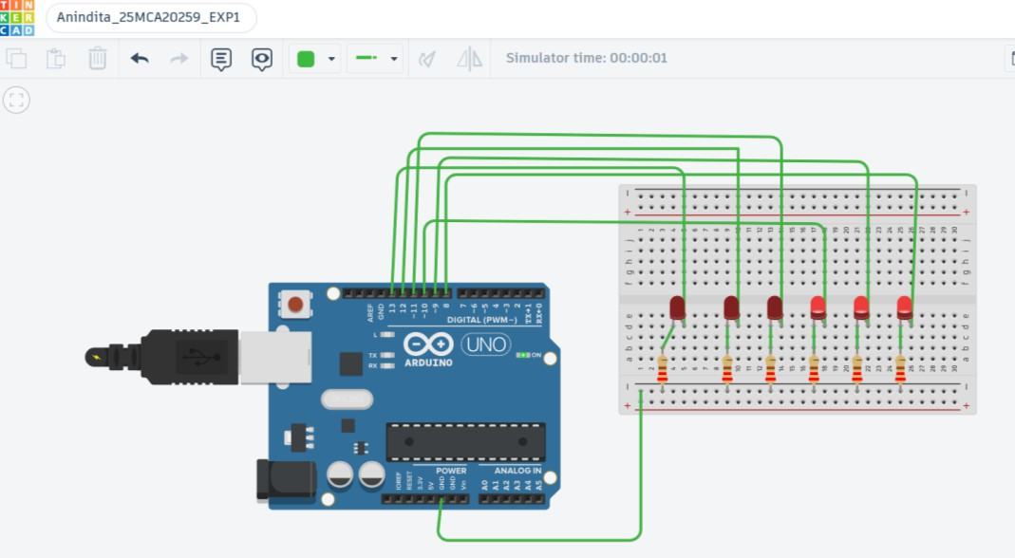
  - T1, T3 and T5 are in ON conditions and T2, T4 and T6 are in OFF conditions.
Coding: int led1 = 13; int led2 = 12; int led3 = 11; int led4 = 10;

int led5 = 9; int led6 = 8;
void setup(){
//setting all pins as output pinMode(led1 , OUTPUT); pinMode(led2 , OUTPUT); pinMode(led3, OUTPUT); pinMode(led4 , OUTPUT); pinMode(led5 , OUTPUT); pinMode(led6 , OUTPUT);
}

void loop(){

digitalWrite(led1, HIGH); digitalWrite(led2 ,LOW); digitalWrite(led3 ,HIGH);

digitalWrite(led4 , LOW); digitalWrite(led5 , HIGH); digitalWrite(led6 ,LOW);

Output:
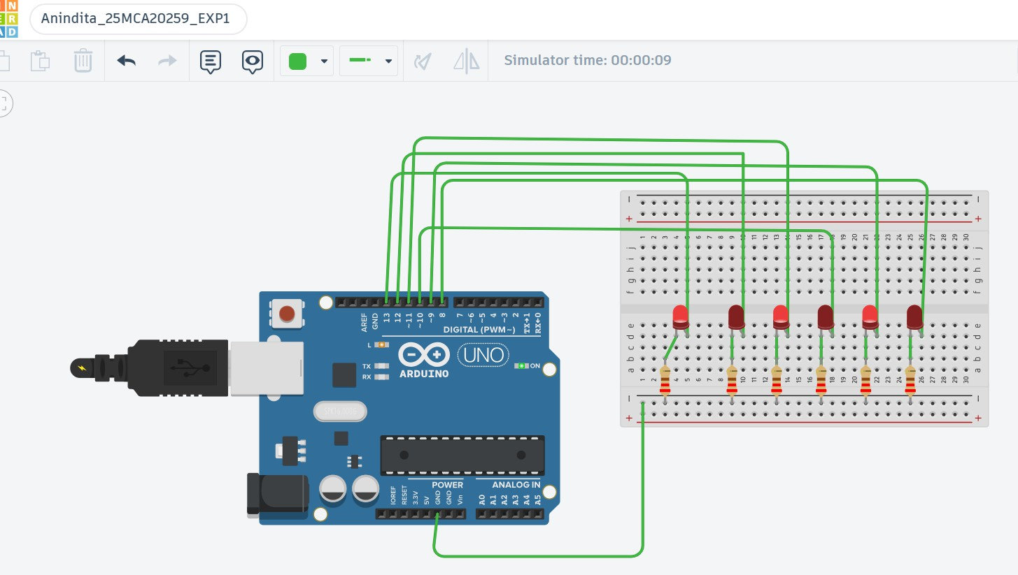
  - T1, T3 and T5 are in OFF conditions and T2, T4 and T6 are in ON conditions.

Coding:
int led1 = 13;

int led2 = 12; int led3 = 11; int led4 = 10; int led5 = 9; int led6 = 8;
void setup(){
//setting all pins as output pinMode(led1 , OUTPUT); pinMode(led2 , OUTPUT); pinMode(led3, OUTPUT); pinMode(led4 , OUTPUT); pinMode(led5 , OUTPUT); pinMode(led6 , OUTPUT);
}

void loop(){

digitalWrite(led1, LOW); digitalWrite(led2 ,HIGH); digitalWrite(led3 ,LOW);

digitalWrite(led4 , HIGH); digitalWrite(led5 , LOW); digitalWrite(led6 , HIGH);

delay(2000);
}

Output:
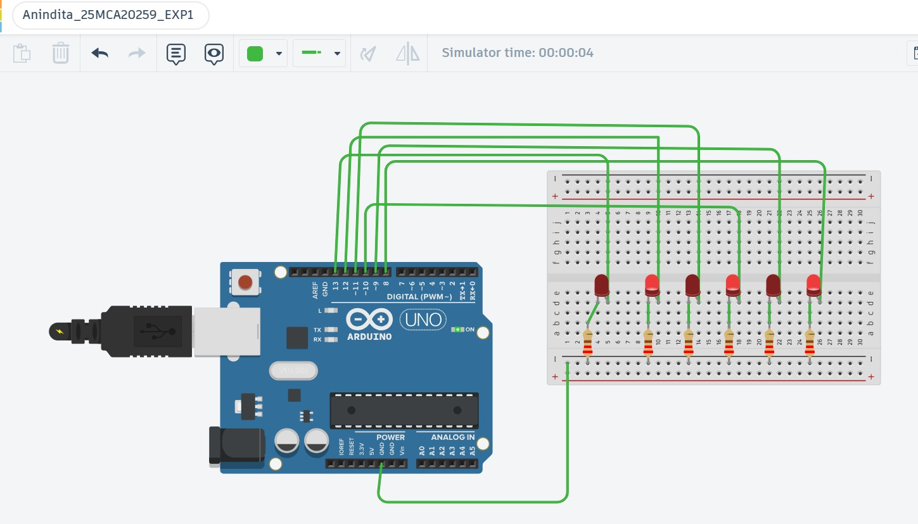

Learning outcomes :
  - Components of Arduino Uno R3.
  - Connecting breadboard , Arduino Uno R3, and led by using Jumper Wires.
  - Writing C++ code to customize working of LEDs in circuit using TinkerCAD.

